Getting started with ESP-IDF on IDE Arduino

1. Install Arduino IDE

Download and install the Arduino IDE for your PC platform

<https://www.arduino.cc/en/software>

1. Configure Arduino preferences with Espressif IDE package

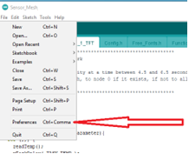

In the “Additional Boards Manager URLs:” box enter <https://dl.espressif.com/dl/package_esp32_index.json>

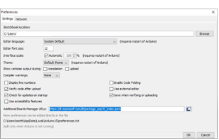

1. Install ESP32 in Arduino Manager

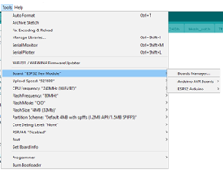

Search for ESP32

Select install

1. Install Libraries in Arduino library tree

1. Open Temp sensor source code

Edit Config.h file SENSOR_NUMBER such that Main node = 0, Sensor1 = 1, Sensor2 = 2 etc.

1. Select ESP32 board COM port

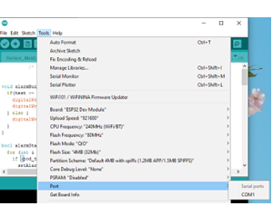

1. Compile and Flash software onto ESP32 board

